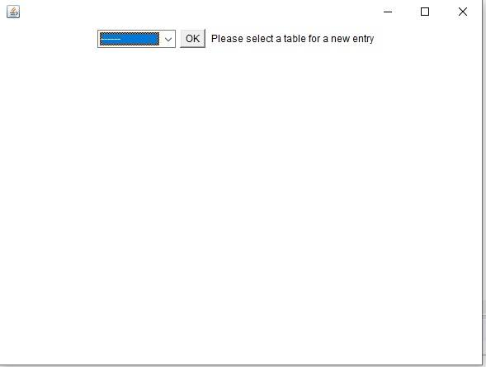
Grid Disturbance Database

This project is divided between a Java prototype, HTML pages, MySQL codes to interact with databases and a Django project to create the final HMI (Human-Machine Interface) that is to be used by the clients. The first aim of this project is to give clients a Proof of Concept, as the real project is currently under development by RTE and other similar firms in Europe, in order to create a common database on a European scale, in order to improve the response to grid disturbances in electric networks. Instead of continuously simulating single disturbances in the network by using the “n-1” algorithm, clients may benefit from past experiences of similar problems in order to deal with them more effectively.
As a result this project was developed while keeping in mind the objective to create a Proof of Concept. Consequently this project went through several steps, always decreasing the complexity whist improving its functionality and the interaction between all its different elements. Below is explained how each part works and interacts with other parts.

I. Java prototype
The Java prototype is meant to show what the HMI would ideally look like and how it would ideally work. However this prototype doesn’t yet show the full extent of the ideal version of the interface. Actually it could be simplified by having only one main app, in which the choices in the different drop-down lists influence the display. For example the first choice of data type would change the characteristics we can choose in the next text boxes.

You enter the main application, where you can choose what type of data you want to enter : ‘Grid Disturbance’, ‘Fault’, ‘Outage’ or ‘Interruption’. Depending on the answer a new window will open, in which you can enter the characteristics of the data you want to add to the database.

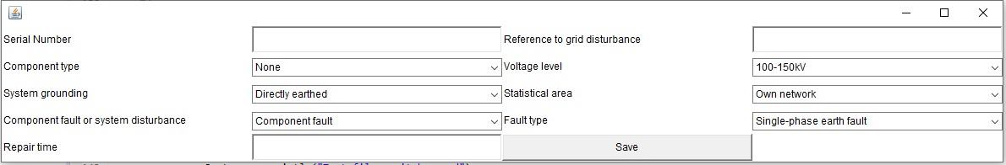
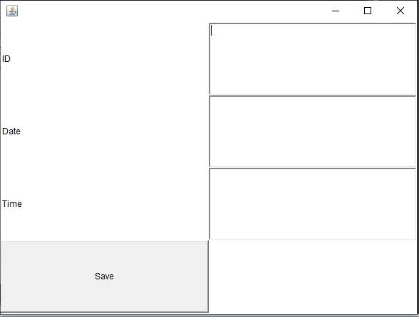
A. Grid disturbance

In the ‘Grid Disturbance’ window you may enter the ID, the date and time of occurrence of the grid disturbance you want to upload to the database.
All information regarding the format of the characteristics can be found in the ‘HVAC_guidelines_2018’ or in the HTML pages. Once all known information has been written, you can ‘Save’ it in the database, which can be found in ‘ToSave.txt’.

B. Fault
In the ‘Fault’ window, you may enter the serial number, the reference to the grid disturbance this fault caused and the repair time, but also choose the component type, the voltage level, the system grounding, the statistical area and fault, and choose between component fault or system disturbance with drop-down lists.
All information regarding the format of the characteristics can be found in the ‘HVAC_guidelines_2018’ or in the HTML pages. Once all known information has been written, you can ‘Save’ it in the database, which can be found in ‘ToSave.txt’.

C. Outage
In the ‘Outage’ window, you may enter system unit number, the reference of the fault causing th outage, the amount of energy not supplied, the duration of interruption and the duration of outage, but also choose the type of system unit, the characterisation of the distance and the characterisation reclosing with drop-down lists.
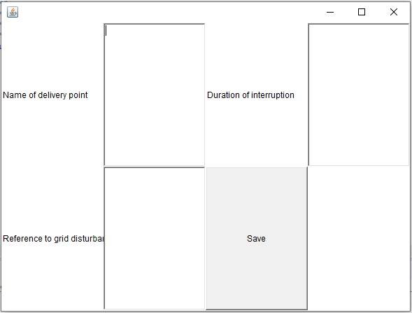
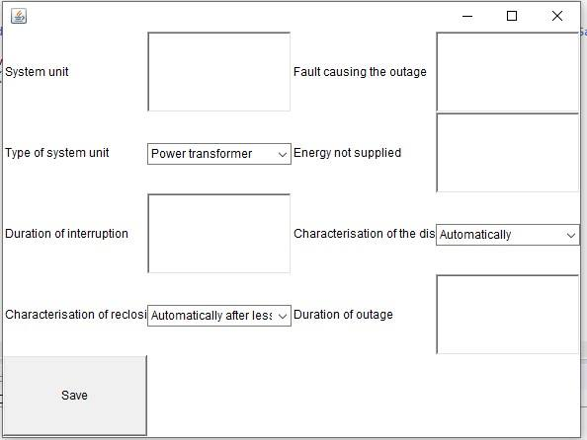

All information regarding the format of the characteristics can be found in the ‘HVAC_guidelines_2018’ or in the HTML pages. Once all known information has been written, you can ‘Save’ it in the database, which can be found in ‘ToSave.txt’.

D. Interruption

In the ‘Interruption’ window, you can enter the name of the delivery point affected by the interruption, its duration and the reference of the grid disturbance created by this interruption.
All information regarding the format of the characteristics can be found in the ‘HVAC_guidelines_2018’ or in the HTML pages. Once all known information has been written, you can ‘Save’ it in the database, which can be found in ‘ToSave.txt’.

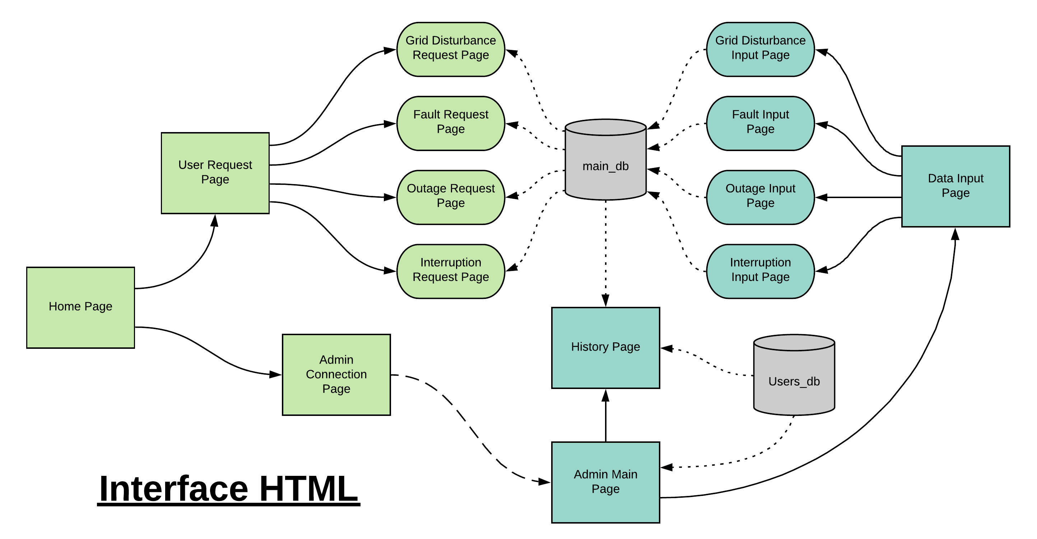
II. HTML pages
The HTML pages of this project are the basis of the final HMI interface, as the Django project will directly use them as its interface. They are linked as described in the chart below.
Currently we simplified this interface by dividing pages based on the type of data, as right now the Django project is devoid of any drop-down lists. On the contrary you may see the semi-final version of the interface in the Java prototype.

